Monday, March 26, 2012

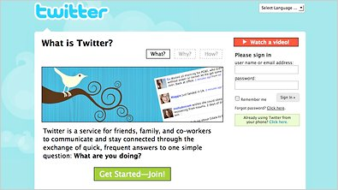
Twitter, which was created by a 10-person start-up in San Francisco called Obvious is a mixture of messaging, social networking, micro blogging and “presence,” shorthand for the idea that people should enjoy an “always on” virtual omnipresence.
Twitter’s rapid growth made it the object of intense interest. “Twitterers” or “tweeters” send and receive short messages, called “tweets,” on Twitter’s Web site, with instant messaging software, or with mobile phones.
When a user is logged in through the Web or a cell phone, it asks one simple question, “What are you doing?” Users answer in 140 characters or fewer. While some of these tweets are meaningful, most are ordinary, like “Sure it is pretty hot today”.
Unlike most text messages, tweets are routed among networks of friends. Strangers, called “followers,” can also choose to receive the tweets of people they find interesting.
In December, 2011, Twitter announced changes to make the messaging service simpler, faster and more personal. The company redesigned the software because many people know about Twitter but do not understand how to use the service.
With more than 200 million accounts, Twitter is part of an elite group of social Web start-ups that have flourished in recent years by rapidly attracting users.
Comprehension questions (à répondre en français)
- Quelle est la source du document ? Quelle est la date de publication?
- Quel en est le sujet ?
- Qu’est-ce qu’un “tweeter”?
- Combien de caractères maximum composent un tweet?
- Qu’est-ce qui différencie un tweet d’un courrier électronique?
- Peut-on dire qu’il s’agit d’une entreprise en plein essor ou en perte de vitesse?

