Phelps feels like a "torpedo" in suit he will use for London 2012

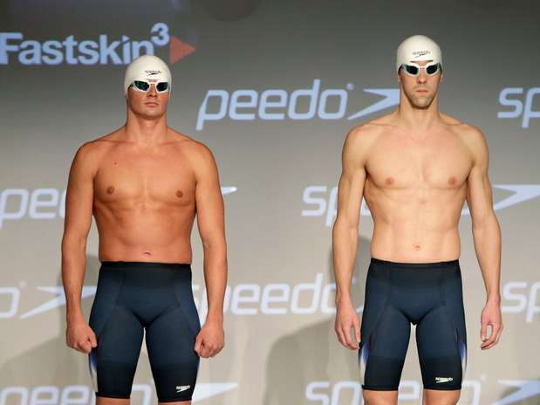
Ryan Lochte and Michael Phelps helped unveil the new suits.
Photo: AP

The American swimmer, Michael Phelps, has presented the new bathing suit, which goes from his waste to his knee that he will use in the London 2012 Olympic Games and that, according to him, makes him feel "like a torpedo."
The winner of eight gold medals in Beijing 2008 has declared that the London Games, the fourth in his career, will be the last Olympics in which he competes.
"From the second I got in the water I felt faster stronger, much more confident and powerful, ready to begin swimming faster," said Phelps in a presentation for the new Speedo bathing suit, the Fast skin 3 Racing System.
"Upon putting on the new equipment-the cap, goggles, and suit-I feel like a torpedo when I dive into the water, more comfortable and confident," said the American swimmer.

Comprehension questions (à répondre en français)
- Qui est Michael Phelps ? (Son nom, son origine et le sport qu’il pratique)
- Que présentera -t-il aux Jeux Olympiques de 2012 ? Quel est le nom ?
- Combien a-t-il gagné de médailles à Beijing ?
- Que ressent -t-il lorsqu’il est habillé dans cet habit ?

